Assessment

**#Create only one EC2 instance with instance type T3.medium**

**# Update system**

sudo apt update -y && sudo apt upgrade -y

**# Install Java (required for Jenkins)**

sudo apt install openjdk-17-jre -y

java -version

**# Install Git**

sudo apt install git -y

git --version

**# Install Docker**

sudo apt install docker.io -y

sudo systemctl enable docker

sudo systemctl start docker

sudo usermod -aG docker $USER

docker --version

**# Install Kubernetes CLI (kubectl)**

curl -LO "https://dl.k8s.io/release/$(curl -L -s https://dl.k8s.io/release/stable.txt)/bin/linux/amd64/kubectl"

chmod +x kubectl

sudo mv kubectl /usr/local/bin/

kubectl version --client

**# Install eksctl (if you want AWS EKS)**

curl --silent --location "https://github.com/weaveworks/eksctl/releases/latest/download/eksctl_$(uname -s)_amd64.tar.gz" | tar xz -C /tmp

sudo mv /tmp/eksctl /usr/local/bin

eksctl version

**# Install Ansible**

sudo apt install ansible -y

ansible --version

**# Install Jenkins**

curl -fsSL https://pkg.jenkins.io/debian/jenkins.io-2023.key | sudo tee /usr/share/keyrings/jenkins-keyring.asc > /dev/null

echo deb [signed-by=/usr/share/keyrings/jenkins-keyring.asc] https://pkg.jenkins.io/debian binary/ | sudo tee /etc/apt/sources.list.d/jenkins.list > /dev/null

sudo apt-get update

sudo apt-get install jenkins -y

sudo systemctl enable jenkins

sudo systemctl start jenkins

systemctl status Jenkins

Now Jenkins is up at http://<EC2-PUBLIC-IP>:8080

**# Switch to Jenkins user**

sudo su - jenkins

**# Generate SSH Key**

ssh-keygen -t rsa -b 4096 -C "jenkins@apache"

cat ~/.ssh/id_rsa.pub

Add this public key into GitHub → Repo → Settings → Deploy Keys → Add Key (with write access).

**we have to give the visudo permissions to Jenkins**

Jenkins ALL=(ALL:ALL) NOPASSWD: ALL

**Inside Jenkins workspace or infra repo, create apache-setup.yml:**

- hosts: all

become: yes

tasks:

- name: Install Apache

apt:

name: apache2

state: present

update_cache: yes

- name: Start and Enable Apache

service:

name: apache2

state: started

enabled: yes

This is Inventory file: **hosts.ini**

[web]

localhost ansible_connection=local

ansible-playbook -i hosts.ini apache-setup.yml

**We Have to push image to dockerhub:**

git clone https://github.com/akshu20791/apachewebsite.git

cd apachewebsite

# Build image from Dockerfile

docker build -t apache-website:v1 .

# Run container locally

docker run -d -p 8081:80 apache-website:v1

# Test

http://localhost:8081

**If it showing permissions denied then use the below commands to give permissions:**

docker login -u challakumar241

sudo usermod -aG docker jenkins

sudo systemctl restart jenkins

sudo su - jenkins

docker ps

**Re-run your Jenkins build step:**

docker login

docker tag apache-website:v1 <your-dockerhub-username>/apache-website:v1

docker push <your-dockerhub-username>/apache-website:v1

**before doing this make sure you have a cluster with nodes if you don't have create it.**

**first we have to install aws cli**

# Update and install dependencies

sudo apt update -y

sudo apt install unzip curl -y

# Download AWS CLI v2 installer

curl "https://awscli.amazonaws.com/awscli-exe-linux-x86_64.zip" -o "awscliv2.zip"

# Unzip the installer

unzip awscliv2.zip

# Run the installer

sudo ./aws/install

# Verify installation

aws --version

**now we have to install eksctl now and then create cluster**

# Install eksctl

curl -sL "https://github.com/eksctl-io/eksctl/releases/latest/download/eksctl_$(uname -s)_amd64.tar.gz" -o eksctl.tar.gz

tar -xzf eksctl.tar.gz -C /tmp

sudo mv /tmp/eksctl /usr/local/bin

eksctl version

**# Create a cluster (takes ~15–20 mins)**

eksctl create cluster --name Kumar-eks --region us-east-1 --nodes 2 --node-type m7i-flex.large

**Create deployment.yml using vi command:**

apiVersion: apps/v1

kind: Deployment

metadata:

name: apache-website

spec:

replicas: 2

selector:

matchLabels:

app: apache-website

template:

metadata:

labels:

app: apache-website

spec:

containers:

- name: apache-website

image: <your-dockerhub-username>/apache-website:v1

ports:

- containerPort: 80

---

apiVersion: v1

kind: Service

metadata:

name: apache-service

spec:

selector:

app: apache-website

ports:

- protocol: TCP

port: 80

targetPort: 80

type: LoadBalancer

**kubectl apply -f deployment.yaml**

**kubectl get deployments**

**kubectl get pods**

**kubectl get svc**

**Copy the LoadBalancer EXTERNAL-IP and open in browser → you should see your Apache website.**

**Generate kubeconfig for your EKS cluster, This creates a kubeconfig file that points to your EKS cluster.**

mkdir -p /var/lib/jenkins/.kube

aws eks update-kubeconfig --name Kumar-eks --region us-east-1 --kubeconfig /var/lib/jenkins/.kube/config

sudo chown -R jenkins:jenkins /var/lib/jenkins/.kube

sudo chmod 600 /var/lib/jenkins/.kube/config

sudo su - jenkins

kubectl get nodes

**Now we have to build the pipeline by pushing the files which we have created using playbooks. then build the pipeline using the GitHub repo. Add jenkinsfile in your repo and build the pipeline in it.**

**Add the GitHub and docker credential in Jenkins. then click on build.**

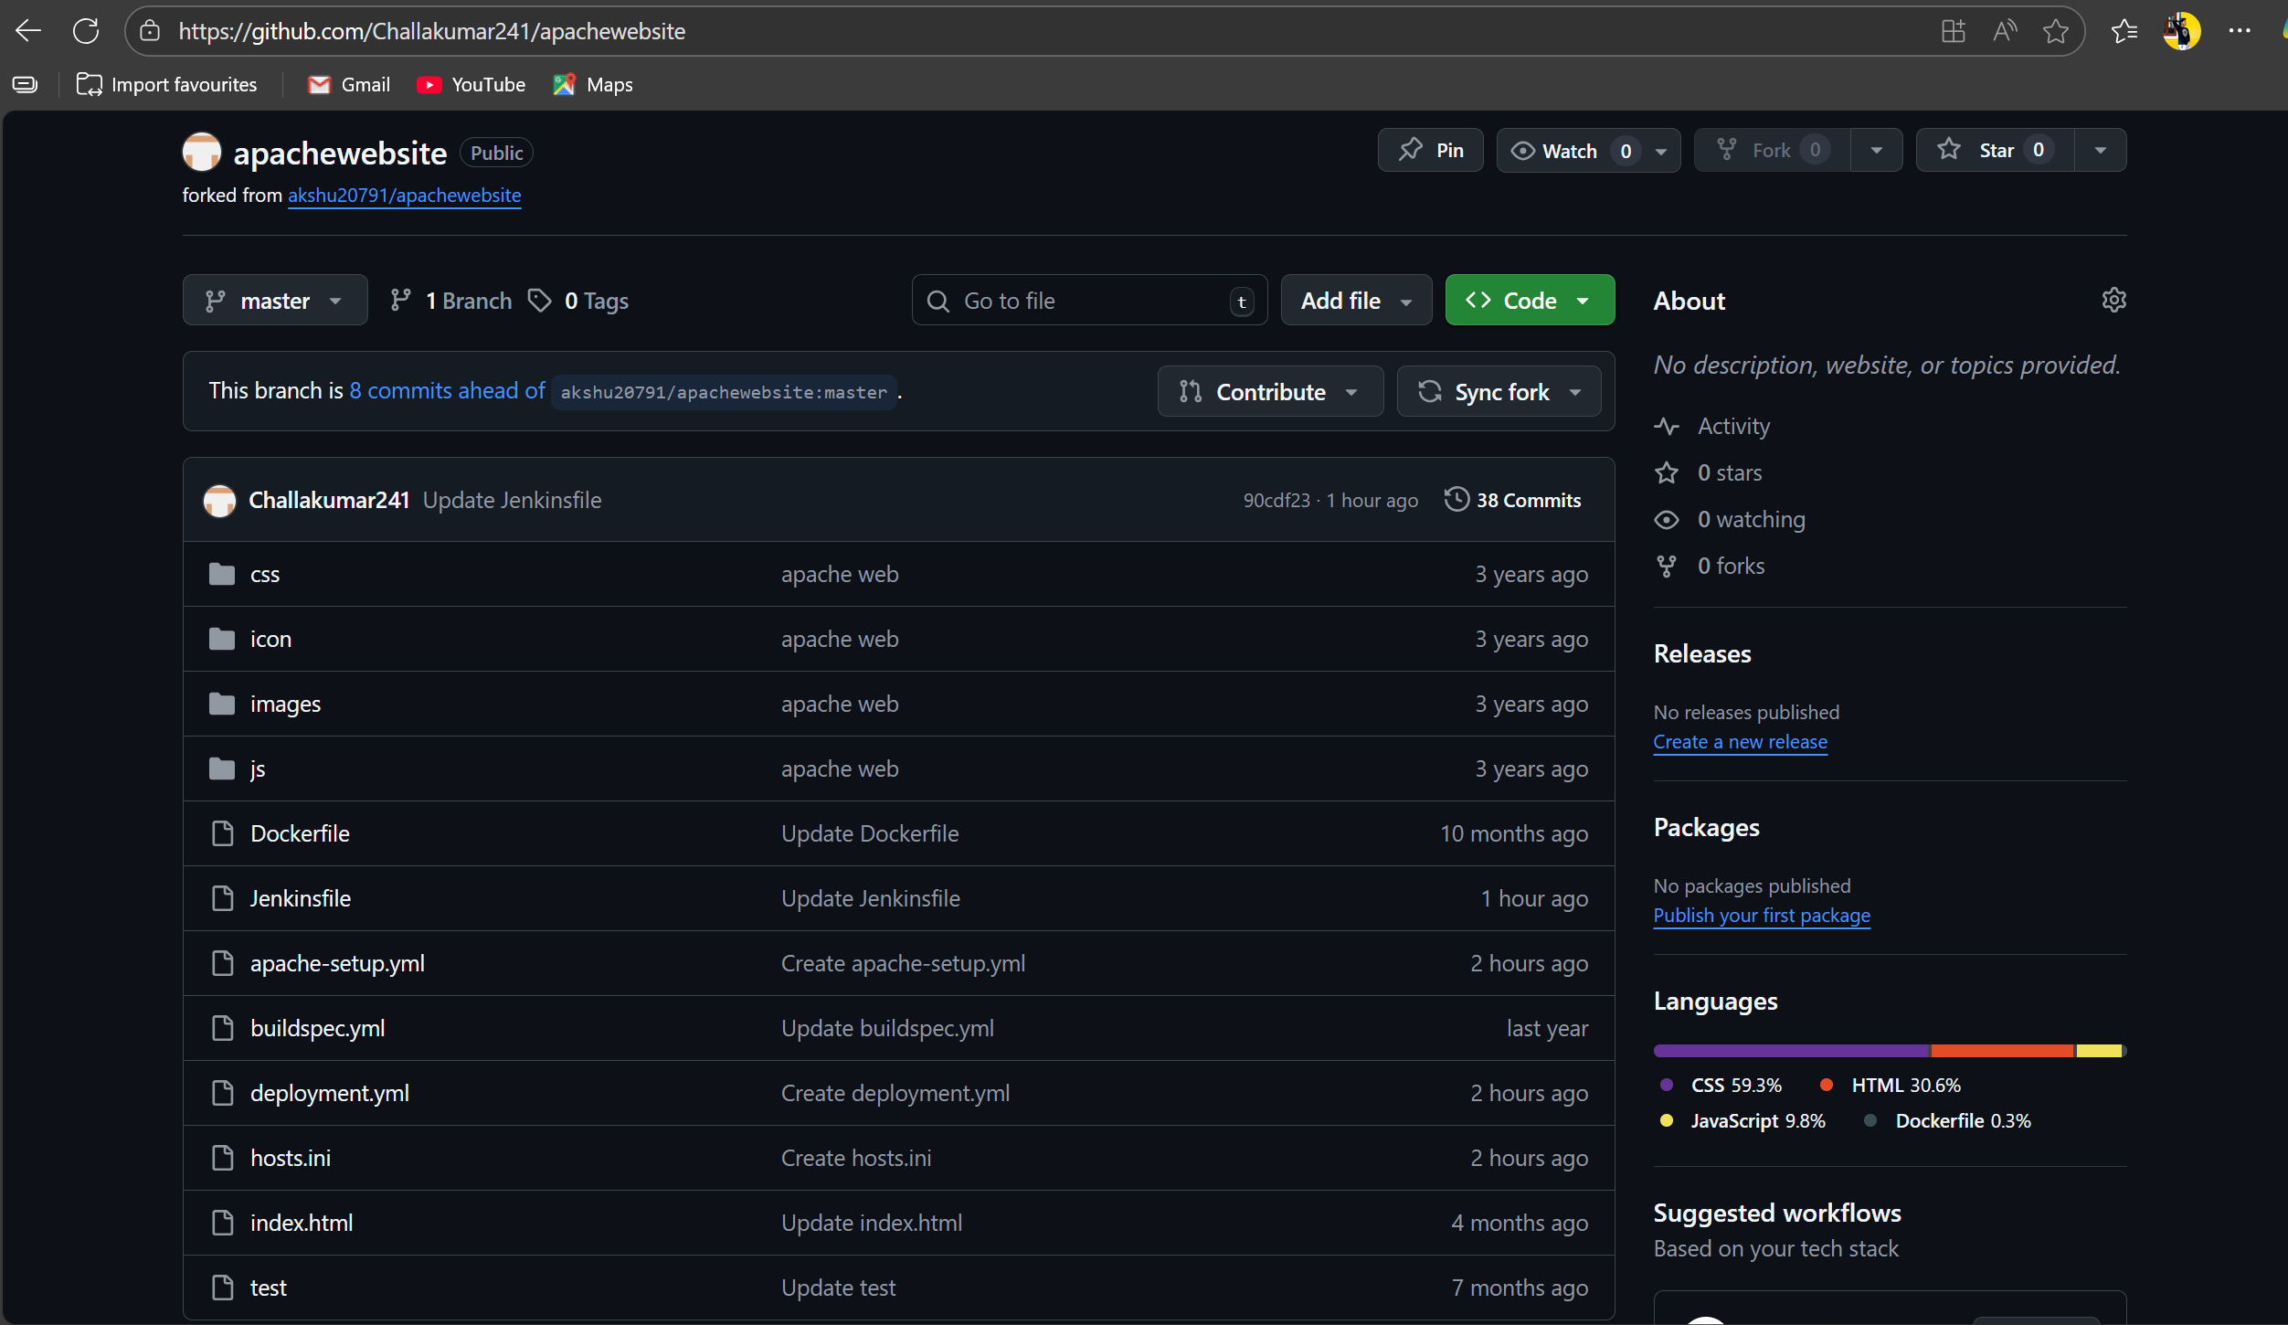





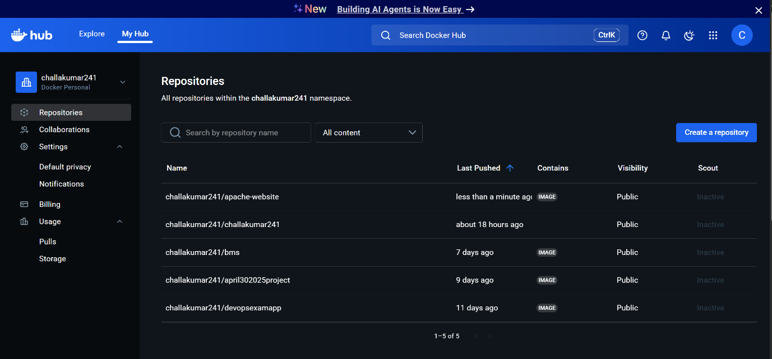

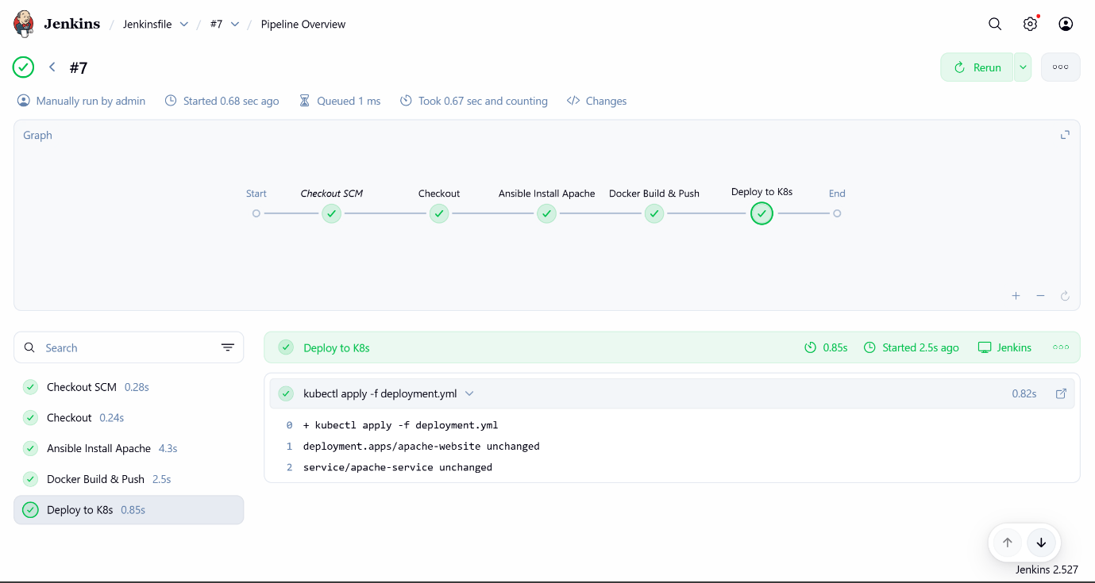

**Pipeline:**

pipeline {

agent any

stages {

stage('Checkout') {

steps {

git branch: 'master', url: 'https://github.com/Challakumar241/apachewebsite.git'

}

}

stage('Ansible Install Apache') {

steps {

sh 'ansible-playbook -i hosts.ini apache-setup.yml'

}

}

stage('Docker Build & Push') {

steps {

withCredentials([usernamePassword(credentialsId: 'dockerhub', usernameVariable: 'DOCKER_USER', passwordVariable: 'DOCKER_PASS')]) {

sh """

echo $DOCKER_PASS | docker login -u $DOCKER_USER --password-stdin

docker build -t apache-website:v1 .

docker tag apache-website:v1 $DOCKER_USER/apache-website:v1

docker push $DOCKER_USER/apache-website:v1

"""

}

}

}

stage('Deploy to K8s') {

steps {

sh 'kubectl --kubeconfig=/var/lib/jenkins/.kube/config apply -f deployment.yml'

}

}

}

}